

**ASSEMBLY INSTRUCTIONS**

**Heritage/Langdale 115cm Square Fire Pit Inlaid Casual Ceramic Dining Table with Beads (GT-11472-ARG)**

**( 68210145 / 68211145 / 68210146 / 68211146 / 68114150 / 68115150 )**

**ATTENTION:**

1. Please read these instructions carefully before assembly
2. Aluminium is a soft metal and over tightening may strip the thread or break the part
3. **DO NOT** use power tools
4. Please allow 30 minutes for assembly
5. Although assembly only requires 1 person it is advised that a second person be present to help turn the table over and into position when fully assembled

**ASSEMBLY STEPS:**

1. Turn table top over and put onto a soft clean surface, be careful of the glass fixed on table top and no need to take out of the glass
2. **LOOSELY** attach base section (B) to table top (A) with bolts (E) and big flat washers (F) using Allen key (I) **DO NOT TIGHTEN THE BOLTS AT THIS STAGE**
3. **LOOSELY** attach the igniter switch with bolts (E) and big flat washers (F) using Allen key(I)
4. Tighten all bolts one by one using Allen key, being careful not to over tighten any as this will cause the thread to become damaged
5. Turn table top over and place in desired position, be careful of the glass fixed on table top while turning over the table
6. Push the door on the base open along the track, connect the gas pipe then put the gas tank on the track and push to close the door
7. Pour the bag of glass beads into fire pit
8. Put the centre glass (C) on top of the fire pit
9. Fire guard: fix 4pc glass (G) onto the glass clips (H). Note: When installing the glass clips, the direction of the clip on the same piece of glass must be in reverse.
10. Put the assembled fire guard on the correct position on table top, the table is assembled completely.

|  |  |  |  |  |  |  |  |  |  |  |  |
| --- | --- | --- | --- | --- | --- | --- | --- | --- | --- | --- | --- |
| **Component’s** | | | | |  | **Fixings** | | | | | |
| **Parts List** | | **Parts Picture** | **Description** | **Q’ty** | **Part no** | **Parts list** | **Parts Picture** | **Description** | **Q’ty** | **Part no.** |
| **A** | |  | **Table Top with Glass** | **1** | **68210145A**  **68210146A**  **68114150A** | **G** |  | **Fire Guard Glass** | **4** | **68210145G** |
| **B** | |  | **Base** | **1** | **68211145B**  **68211146B**  **68115150B** | **H** |  | **Glass clip** | **8** | **2100042** |
| **C** | |  | **Centre glass** | **1** | **68210145C**  **68210146C**  **68114150C** | **I** |  | **Allen key** | **1** | **2002191** |
| **D** |  | | **Glass beads** | **1** | **68210145D** |  |  |  |  |  |
| **E** |  | | **M6*20 bolts** | **8** | **1017162** |  |  |  |  |  | |
| **F** |  | | **Flat washer** | **8** | **1061162** |  |  |  |  |  | |

**For more information regarding maintenance of your furniture please visit** <https://www.hartmanuk.com/home>



**ASSEMBLY INSTRUCTIONS**

**Heritage/Langdale 115cm Square Gas Inlaid Casual Ceramic Dining Table with Beads (GT-11472-ARG)**

**( 68210145 / 68211145 / 68210146 / 68211146 / 68114150 / 68115150 )**

2

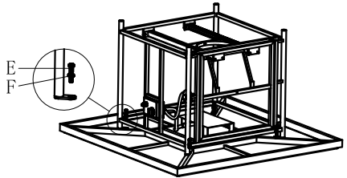

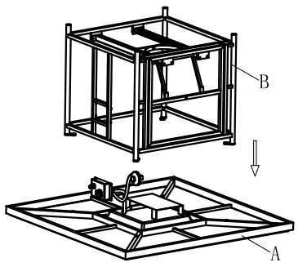

1

4

3

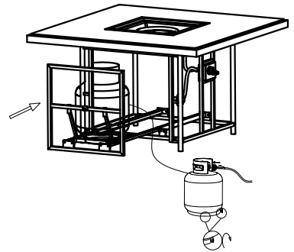

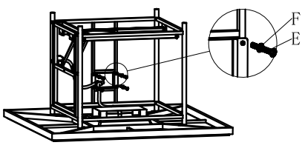

5

6

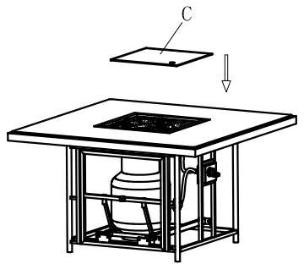

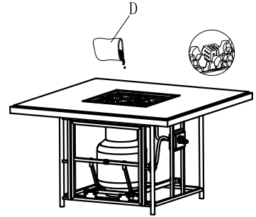

8

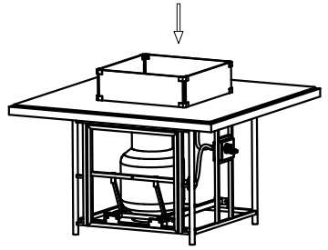

7

